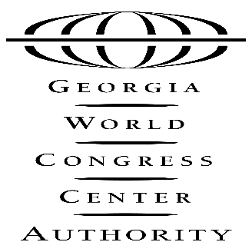

PRELIMINARY AGENDA

GWCCA BOARD OF GOVERNORS MEETING
July 30, 2019
Authority Boardroom
12:30 P.M.

- Call to Order and Welcome

- Approval of Minutes – June 25, 2019 (ACTION ITEM)

- June 2019 Financial Report

- Sales Update

- Levy End of Year Update

- Hotel Project – Finance Committee Recommendation (ACTION ITEM)

- Date of Next Meeting – Tuesday, August 27, 2019

285 ANDREW YOUNG INTERNATIONAL BOULEVARD, N.W. ATLANTA, GA 30313.1591 404.223.4000 FAX 404.223.4011
www.gwcc.com

