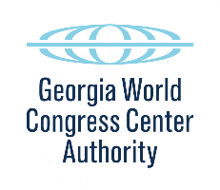

PRELIMINARY AGENDA

GWCCA BOARD OF GOVERNORS
EXECUTIVE COMMITTEE MEETING
February 14, 2020
1:00 p.m.
Conference Call

- Call to Order and Welcome
- January 21, Meeting Minutes Approval (Action Item)
- Development Budget Update – Drew/Skanska
- Plan of Finance Updates – Bill Corrado
- QMA Update – Frank Jones
- Bond Documentation Agreements – Matt Nichols
- Skanska GMP Agreement – David Jensen
- HDBY Access Agreement – Pargen Robertson
- Schedule – Theonie Alicandro
  - Critical Path Items to Bond Closing
- Adjourn

285 ANDREW YOUNG INTERNATIONAL BOULEVARD, N.W. ATLANTA, GA 30313.1591 404.223.4000 FAX 404.223.4011
www.gwcc.com

