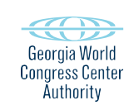
Preliminary Agenda
GWCCA EXECUTIVE COMMITTEE
Tuesday, April 25, 2023
GWCCA Administration Conference Room
11:00 am

I. Call to Order and Welcome

II. Approval of Minutes – March 22, 2023 (ACTION ITEM)

III. Signia by Hilton Atlanta Hotel Update

IV. Adjourn

