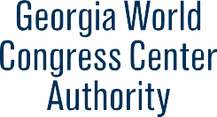
PRELIMINARY AGENDA
GWCCA Board of Governors Meeting
Tuesday, April 25, 2023
GWCCA Authority Board Room
12:30 p.m.

I. Call to Order and Welcome

II. Approval of Minutes – March 28, 2023 (ACTION ITEM)

III. Authority Business

- Financial Update – March 2023

- 2023 Legislative Session Update

- Signia by Hilton Atlanta Construction Update

- Projects Update

- Resolution – Trane U.S.A. Inc. Agreement (ACTION ITEM)

- Resolution – College Football Hall of Fame Storage License Agreement (ACTION ITEM)

IV. Adjourn

Date of Next Meeting – Tuesday, May 23, 2023

